Princess Sumaya University for Technology

King Abdullah II Faculty of Engineering

Electrical Engineering Department

|  |
| --- |
| **Smart Water Tank Project** |

|  |  |  |
| --- | --- | --- |
| *Authors:* |  | *Supervisor:* |
| Rahaf AlHaddadein  Mirna Jamalieh  Dania Abulhassan | 20190076  20190629  20190478 | Dr. Belal Sababha |

*January 23, 2023*

***Abstract***

*Due to the current state of the ecosystem in Jordan water management is necessary. Water is one of the main commodities that is wasted too much. Despite being the focus of our lives it receives insufficient attention. Engineers play important roles in solving such a problem by finding many ideas. Embedded systems can help with those types of problems, the main focus of this project is working on making the water tanks work smartly embedded systems are able to reduce the waste of water by using specific sensors that will give the user information about the water tank making it easier to track.*

Table of Contents

1 Introduction 2

2 Background 2

3 Problems and recommendations 6

5 Design 7

6 Conclusions 18

6 References 19

# Introduction

Water has a significant impact on our lives, thus it's crucial to limit its use. To complete this project, we used our knowledge from the embedded systems design course to create a system to manage water use. Embedded systems are essential to the development of our project. Whether they are house-based or situated in remote locations, water tanks are the focus of our project. First, there is a serious water deficit because regular water tanks can’t control or check the water level. To determine whether there is enough water, this project will use a water level sensor that is interfaced with a microcontroller to measure the amount of water. There are often two water tanks, necessary, water is pumped from the lower tank to fill the upper tank.

The procedure that this project is using is that a microcontroller takes readings from the ultrasonic sensor to measure the level of water by calculating the distance, according to the readings that have been taken from the ultrasonic the user can tell whether the water level is high, or low by referring to the lights, green, yellow, red which means that the tank is almost full, the distance is low. yellow, red means that the distance is medium and the tank is half full, and finally red, which means that the tank is almost empty, and the distance is high therefore the pump powered by a power source is on, the LCD will show the distance measured on the screen and temperature taken from the temperature sensor also, PH level measured by the PH sensor to check the pH of the water can be used to determine whether there is an object in the tank making the water unclean or even whether calcium or magnesium carbonates are present in unusually high concentrations. A pH sensor will therefore be utilized as well. Due to this, a filter that is powered by a power source attached to the microcontroller will also be employed. Keep in mind that this filter will only function if it is required to reduce power usage. However, a lock pad will be utilized to safeguard the tank itself, preventing passers from opening the tank and stealing water without the owner's consent.

# Background

1. **The Micro-controller PIC16f877A:**

It is regarded as one of the most popular microcontrollers available. This microcontroller is incredibly simple to operate, and programming it is also quite straightforward of the major advantage is that it may be write-erased as many times as necessary because FLASH memory technology is used. It has 40 pins altogether, 33 of which are used for input and output. The PIC16F877A is used in many microcontrollers. Additionally, PIC16F877A is frequently utilized in digital electrical circuitry. Many different types of devices use the PIC16f877a. It is used by a range of industrial instruments, smart sensors, and safety equipment. It also features an EEPROM, which enables it to permanently store some information, including related data and the transmitter and receiver frequencies. It is inexpensive and easy to use this controller. It may be used in applications for microprocessors and timers and other areas where microcontrollers haven't been used before thanks to its adaptability. A smaller set of 35 instructions is included. It has a maximum operating frequency of 20 MHz. The operating voltage ranges between 4.2 and 5.5 volts. If it receives more voltage over 5.5 volts, it might be permanently damaged. It, like with other PIC18F46K22 and PIC18F4550 chips, lacks an inbuilt oscillator. Approximately 100mA of maximum current can be linked or sourced by each PORT. As a result, the PIC16F877A's GPIO pins each have a 10-mile ampere current limit. The brain is in control of everything in this enterprise, after all.

Figure (1): pic microcontroller 16F877A

1. **Ultrasonic sensor:**

This sensor has a transmitter and a receiver, and the transmitter transmits sound waves at a frequency that is higher than the frequency at which a person can recognize sounds. Thus, the sound that the transmitter emits won't ever be audible to humans. The major pins of this sensor, the trigger and echo, are more than just three.

The echo signal becomes (1) after it was (0) and remains (1) until the echo of sound waves comes back to the receiver instantly, at which point the echo pulse signal returns to (0). When the transmitter delivers one pulse signal, the transmitter sends eight pulse signals (sound waves) (0). Therefore, it is feasible to calculate the distance between an ultrasonic sensor and an item that reflects sound waves by considering the time of the echo pulse signal and the speed of sound waves as data.

Figure (2): Ultrasonic sensor

1. **PH sensor:**

By monitoring the activity of the hydrogen ions, pH sensors keep track of the pH level. The activity's acidity or alkalinity is assessed using the pH scale of 0 to 14 in comparison to pure water, a neutral solution. PH electrode probe has reliable reading accuracy and can provide almost instantaneous reading of pH value. Thus, it can be used in water purification processes. This pH sensor probe is refillable, which means its KCl (potassium chloride) salt solution can be refilled to extend the lifespan of the sensor. The probe has BNC connector which can integrate with majority type of PH meter and controllers, suitable for application in aquarium, hydroponic, aquaponic, laboratory, etc.

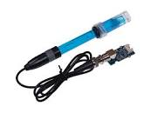

Figure (3): PH sensor

1. **Temperature sensor LM35:**

The main purpose of the temperature sensor, which is a thermally sensitive resistor, is to display a significant, predictable, and accurate change in electrical resistance in response to a change in body temperature. When exposed to a rise in body temperature, thermistors with negative temperature coefficients (NTC) show a drop in electrical resistance, whereas those with positive temperature coefficients (PTC) show an increase in electrical resistance.

Figure (4): Temperature sensor LM35

1. **Water pump:**

A mini water pump, as the name implies, is a small or micro-AC or DC water pump that is frequently employed to pressurize, circulate, or pump water for various purposes.

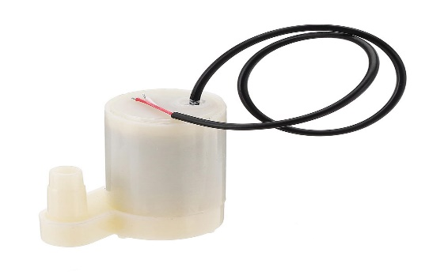

## 

Figure (5): Mini water pump

1. **Relay:**

A relay is a device that activates switches or other devices in response to a tiny current or voltage change. Used to switch signals or power remotely. Input control is often electrically segregated from active power control. The input signal controls whether the switch is either open or not**.**

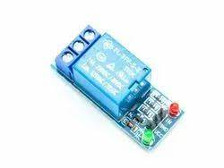

Figure (6): Relay

1. **Op-Amp:**

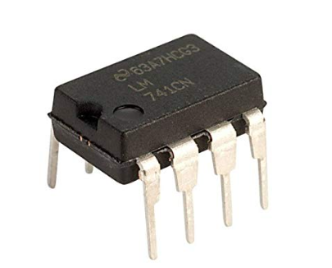Op-amps are extremely valuable devices in electronics, especially when it comes to connecting analog and digital technology in embedded systems. An operational amplifier, also called as an op-amp or op amp, is an integrated circuit primarily designed for performing analogue computations. It has a very high voltage gain

Figure (7): Op-Amp ua741

# Problems and recommendations

1. The predefined libraries used affected the code programmed as the ports that were predefined and the ports used were somehow used twice. Thus, all ports were changed for the code to work correctly.
2. The ultrasonic sensor is affected by water and humidity. A piece of cork (فلين) was used and placed in the tank as it floats on the top of the water, to reduce the affection of humidity and to build a solid surface to make the ultrasonic sensor work effectively.
3. A keypad and an LCD were supposed to be used as measures of safety, however, the keypad code was working well on Proteus but when done in real life it wasn’t working. This keypad code was intended to lock and unlock the tank door for which the lock is connected to a relay and then to the PIC. A buzzer was also used when the password is entered wrong twice. Unfortunately, this was not implemented in our project. However, a solution of this problem was thought of which is using push buttons as a password by entering different patterns.
4. A mobile application using a Bluetooth module was supposed to be used in this project for safety and convenience purposes, the problem faced was that building a Bluetooth module needed an android device that we couldn’t afford.

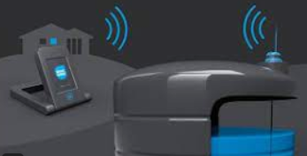

Figure (8): Bluetooth module

# Design

Figure (9): schematic diagram of the system

To start with, figure 6 represents a prototype of the smart water tank project. It consists of a water tank that has the pH sensor inserted in it along with an ultrasonic sensor glued to the lid of the tank. A temperature sensor is also used to measure the temperature of the surrounding environment. The water pump is placed in another water container (representing another tank) to pump water from one tank to another through a tube connected to the pump. Two microcontrollers are used that are responsible for the ultrasonic, LEDs, temperature sensor, and LCD, and the other PIC is responsible for the pH sensor as it has an external circuit for the op-Amp. Note that an external power supply is used for this design with 5V supplied to the PIC and 4.2V supplied to the pump.

The first PIC is programmed to measure the distance using the ultrasonic sensor which is placed on the lid of the tank. A white foam piece is placed in the tank floating on the water which acts as a surface for reflecting the signal sent from the ultrasonic to measure the distance as the ultrasonic can’t see transparent surfaces. After the distance is measured several if statements are used to determine what procedure is done. If the distance is greater than 20cm then a red LED lights up along with the water pump meaning that the tank is empty and water is needed. Another case is that the water is within the range of 13cm to 19cm for which the yellow and red LEDs are lit meaning that the tank is half full, here the pump is not turned on. The last case is when the distance is within the range 0 and of 12cm meaning that the tank is full and the green, yellow ad red LEDs are lit. Furthermore, the temperature sensor is considered an analog sensor and so the voltages are turned into digital readings through conversions. This digital reading is portrayed on the LCD. Note that the LCD is connected to port D, the ultrasonic sensor and the three LEDs, and the pump are connected to port B, and the temperature sensor is connected to port A as is an analog sensor.

Note that, Proteus was used for simulation purposes as shown in figure 7.

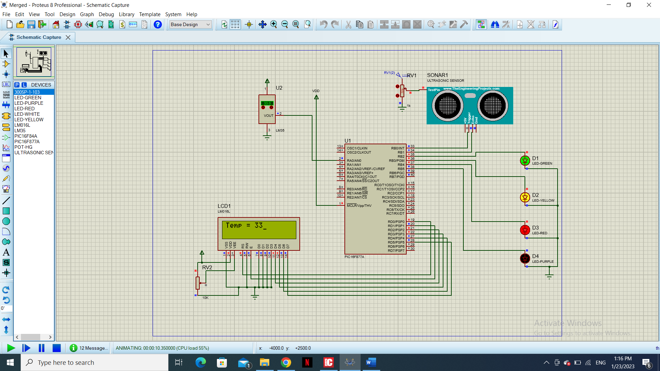

Figure (10): Simulation for the first PIC

The following equations are used for converting the analog temperature readings to digital readings:

For the ultrasonic sensor:

Note that the equation divides the distance by 2 since the ultrasonic sensor measures the time taken for the signal sent from the sensor to the surface and back to the sensor.

**Note that the following code is for the first PIC and all the pin connections are included in the code, also the LCD library is used in this code.**

// Lcd pinout settings

sbit LCD_RS at RD0_bit;

sbit LCD_EN at RD1_bit;

sbit LCD_D7 at RD5_bit;

sbit LCD_D6 at RD4_bit;

sbit LCD_D5 at RD3_bit;

sbit LCD_D4 at RD2_bit;

// Pin direction

sbit LCD_RS_Direction at TRISD0_bit;

sbit LCD_EN_Direction at TRISD1_bit;

sbit LCD_D7_Direction at TRISD5_bit;

sbit LCD_D6_Direction at TRISD4_bit;

sbit LCD_D5_Direction at TRISD3_bit;

sbit LCD_D4_Direction at TRISD2_bit;

/*

RB0 is Trig Pin

RB1 is Echo pin

RB2 is green led pin

RB3 is yellow led pin

RB4 is red led pin

RB5 is for pump

*/

/*RA0 is temp sensor middle pin*/

unsigned int temp_celcius;

char tmp1[7]; // intialize char to store a string of 3 chars

void ATD_init(void);

unsigned int ATD_read(void);

int tmp;

unsigned int temp;

void msDelay(unsigned int);

void usDelay(unsigned int usCnt);

void ATD_init(void)

{

ADCON0=0x41;//ON, Channel 0, Fosc/16== 500KHz, Dont Go

ADCON1=0xC0;//RA0 Analog, others are Digital, Right Allignment

TRISA=0xFF;

}

unsigned int ATD_read(void)

{

ADCON0=ADCON0 | 0x04;

while(ADCON0&0x04);//wait until DONE, channel0

return (ADRESH<<8)|ADRESL;

}

void msDelay(unsigned int msCnt)

{

unsigned int ms=0;

unsigned int cc=0;

for(ms=0;ms<(msCnt);ms++){

for(cc=0;cc<155;cc++);//1ms }

}

void usDelay(unsigned int usCnt)

{

unsigned int us=0;

for(us=0; us<usCnt; us++){

asm NOP;//0.5 uS

asm NOP;//0.5uS

}

}

int findDistance()

{

int distance1 = 0;

TMR1L = 0x00;

TMR1H = 0x00;

PORTB=PORTB|0x01;

usDelay(10);

PORTB=PORTB&0xfe;

while(!RB1_BIT);

T1CON=0x19;

while(RB1_BIT);

T1CON=0x18;

distance1 = (TMR1L | (TMR1H<<8));

distance1 = (distance1*0.034)/2;

return distance1;

}

void main()

{

int distance = 0;

TRISB = 0x02;

PORTB = 0x00;

TMR1L = 0x00;

TMR1H = 0x00;

T1CON=0x00;

ATD_init(); // Initializes the ADC Module for ADC Conversions

T1CON=0x00;

Lcd_Init(); //Intializes the LCD modules

msDelay(250);

Lcd_Out(1,1, " Smart Water");// LCD Will display at row 1 column 1

Lcd_Out(2,2, "Tank"); // LCD Will display at row column 2

msDelay(3200); // Will display this for 2 seconds

Lcd_Cmd(_LCD_CLEAR); // Will clear LCD for new valuse to be displayed

while(1)

{

distance = findDistance();

if(distance >= 20)

{

PORTB = PORTB|0x30;

PORTB = PORTB&0xf3;

//RB4, RB5 are on and RB2, RB3 are off

}

else if(distance <=2 && distance>=0)

{

PORTB = PORTB|0x1c;

PORTB = PORTB&0xdf;

// RB2, RB3, RB4 are on and RB5 is off

}

else if(distance >= 13 && distance <= 19)

{

PORTB = PORTB|0x18;

PORTB = PORTB&0xdb;

//RB3, RB4 are on and RB2, RB5 are off

}

else if(distance >=2 && distance <=12)

{

PORTB = PORTB|0x1c;

PORTB = PORTB&0xdf;

// RB2, RB3, RB4 are on and RB5 is off

}

temp_celcius=ATD_read(void);

temp_celcius=(temp_celcius*0.4887) ;//5000/1023

IntToStr(temp_celcius, tmp1);// will convert values of temp_celcius to tmp1

ltrim(tmp1);

msDelay(20);

Lcd_Cmd(_LCD_CLEAR); // Precaution clear for readings to be displayed

Lcd_Out(1,1, "Temp = ");

Lcd_Out(1,8,tmp1); // I changed column number to display result after above helping string

msDelay(800); // Keep displaying same value for 0.5 sec

Lcd_Cmd(_LCD_CLEAR); // Then clear LCD for new values

}

}

The second PIC is programmed to measure the pH level in the water using the pH electrode E201-C BNC, which is placed inside the water tank. Because the PIC can't read the voltage levels from the pH sensor without amplification, a circuit is made to do that.

In general, the pH sensor comes with an amplification kit, as shown below:

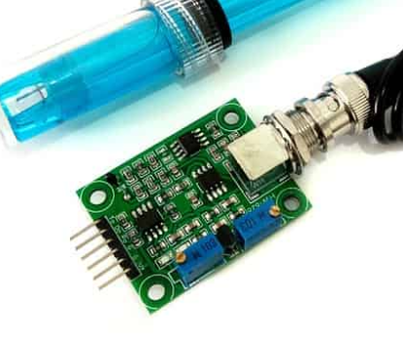

Figure (11): amplification ph board

In this case, the amplification board was not there with the sensor, and so it was built.

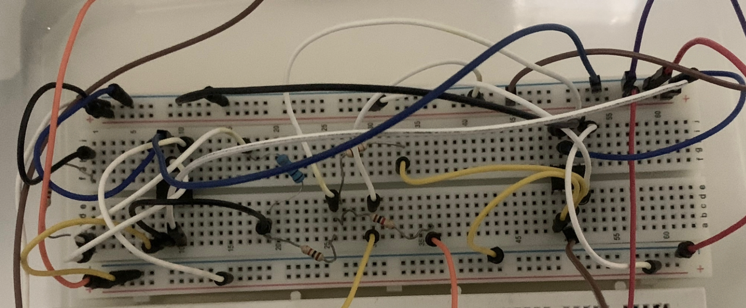

**Op-Amp 741**

Figure (12) : The design of the amplification circuit

The amplification circuit was designed to amplify with a factor of 5 and then an offset equal to 20. To reach the range that could be distinguishable for the PIC. The calculations are based on circuit and the formula shown below:

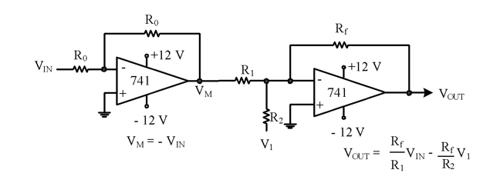

Figure (13): level shifting and scaling circuit

Note that all the resistors used are equal to 1k-ohm which means Vin should be 5V and V1 should be 20 V for the circuit to do its job. Also, the +-12 terminals are set to be +-5V.

Now, as the pH sensor reading has been amplified, it is ready to be interfaced with the 16f877a PIC. That is, RA0 (analog) is connected to the sensor pin connected in series with a 10K-ohm resistor, and RB0 is connected to a LED connected in series with a 320-ohm resistor. As shown below:

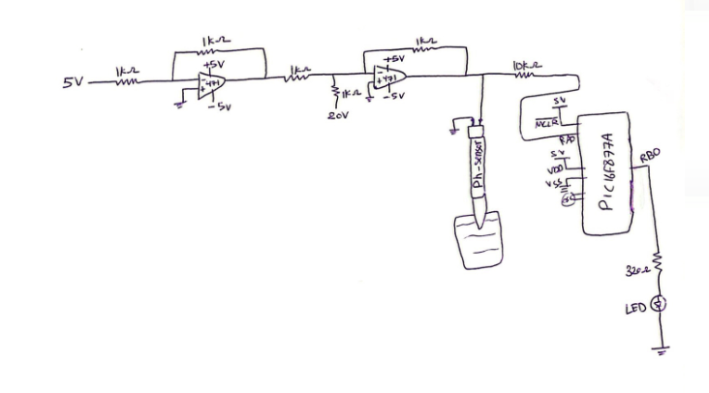

Figure (14) : the ph sensor connections

The code is configured to first convert the analog input from the ph sensor to a digital value, then compare the resulting value to the desired range (to be explained), i.e., if the result is within the range, the program will turn off the LED, otherwise it will turn on the LED.

The desired range is the voltage range compared to the acceptable pH value that was tested at 6.86 ph, and the other solution with a ph of 4 is for showing the non-desired range.

**The following code is for the second PIC for the pH sensor:**

// Set lower and upper limits for pH range*/

float lower_limit = 1.24 ;//set the lower limit to 1240mV

float upper_limit = 1.46; //set the upper limit to 1460mV

unsigned int ATD_read(void);

int pH_value_in_voltage;

unsigned int myreading;

unsigned int myVoltage;

void main() {

// ph is at RA0 (input)

TRISA=TRISA|0x01;

// Configure the ADCON1 register

ADCON1 = 0xCE; // Configure AN0 to analog , right justified

ADCON0 = 0x41; // Enable the ADC module, select AN0 channel , Fosc/16 , don't go

// Set LED pin as output in RB0

TRISB=TRISB&0xfe;

// Loop to continuously read pH sensor

while (1) {

// Read the result

myreading = ATD_read();

myVoltage = (unsigned int)(myreading*5)/1023; //the range bacomes (0-5000)mV

// Check if the voltage corresponds to the pH value is within the desired range

if ( myreading > upper_limit || myreading < lower_limit) {

PORTB = PORTB | 0x01; //turn on LED

}

else

{

PORTB = PORTB & 0xfe; //turn off LED

}

}

}

unsigned int ATD_read(void){

ADCON0 = ADCON0 | 0x04;// GO

while(ADCON0 & 0x04); // Wait for the conversion to complete

return((ADRESH<<8) | ADRESL); //return the result from the ATD conversion

}

Flow chart of the Project design for the PIC:

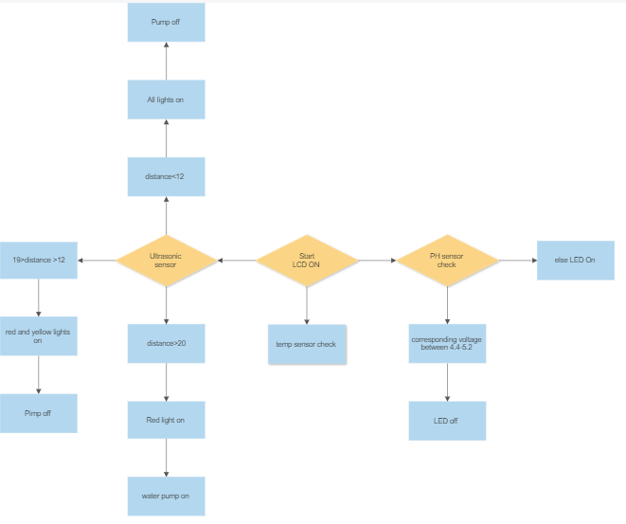

Figure (15): flow chart

# Conclusions

We have been able to achieve our goal of developing an effective system employing the pic16F877A and other parts such as a motor and sensors that might deal with water use in homes in a safe and equitable manner. A two-tank water level and water quality monitoring system that includes embedded systems for real-time monitoring. The system's design and implementation aim to give a low-cost, convenient solution to water waste and water quality determination.

# References

1. Suraksha Sanghavi Follow Student at Shri Neminath Jain Brahmacharyashramas College of Engineering. “Smart Water Tank.” Share and Discover Knowledge on SlideShare, <https://www.slideshare.net/SurakshaSanghavi/smart-water-tank>.
2. Suraksha Sanghavi Follow Student at Shri Neminath Jain Brahmacharyashramas College of Engineering. “Smart Water Tank.” Share and Discover Knowledge on SlideShare, <https://www.slideshare.net/SurakshaSanghavi/smart-water-tank>.
3. Simple Projects. “Interfacing Pic MCU with HC-SR04 Ultrasonic Sensor: MPLAB Projects.” Simple Projects, 19 Nov. 2018, <https://simple-circuit.com/mplab-xc8-hc-sr04-ultrasonic-sensor-pic/>.